Set Item Commission
Path : Billing.petpooja.com >> Menu >> Menu & Discount >> Set Item Commission.
outletwise_link : https://menu.petpooja.com/items/menucommission_list//
Steps to reach Set Item Commission :
Step 1 : Billing.petpooja.com in Steps to reach Set Item Commission : Open your browser and go to billing.petpooja.com.
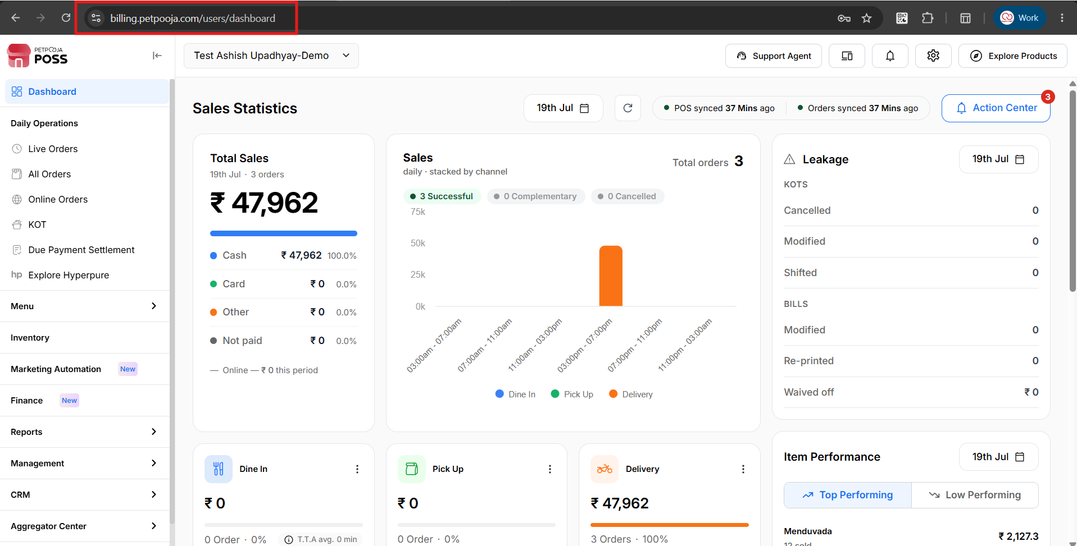
{Image Name: PetPooja Dashboard ,
Description: The highlighted URL indicates that this is the billing.petpooja.com.Here is an image of step 1 Billing.petpooja.com in Steps to reach Set Item Commission.}
Step 2 : Menu in Steps to reach Set Item Commission : Click on the Menu section from the dashboard.
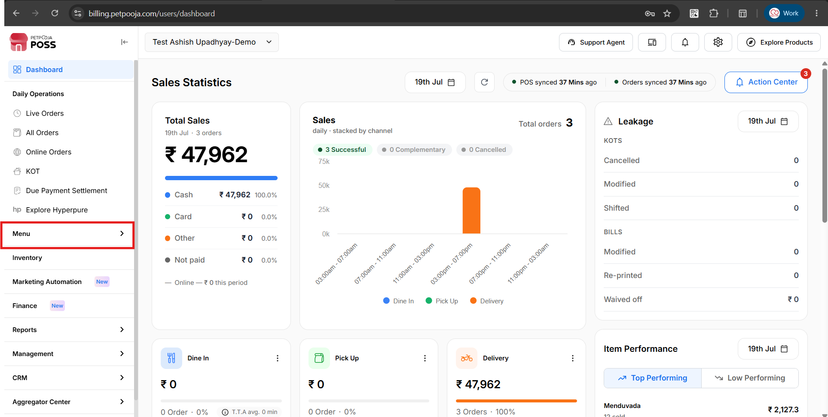
{Image Name: Menu,
Description:This screen shows the Petpooja dashboard with the "Menu" section highlighted. Here is an image of step 2 Menu in Steps to reach Set Item Commission.}
Step 3 : Menu & Discount in Steps to reach Set Item Commission : Inside the Menu section, click on Menu & Discount.
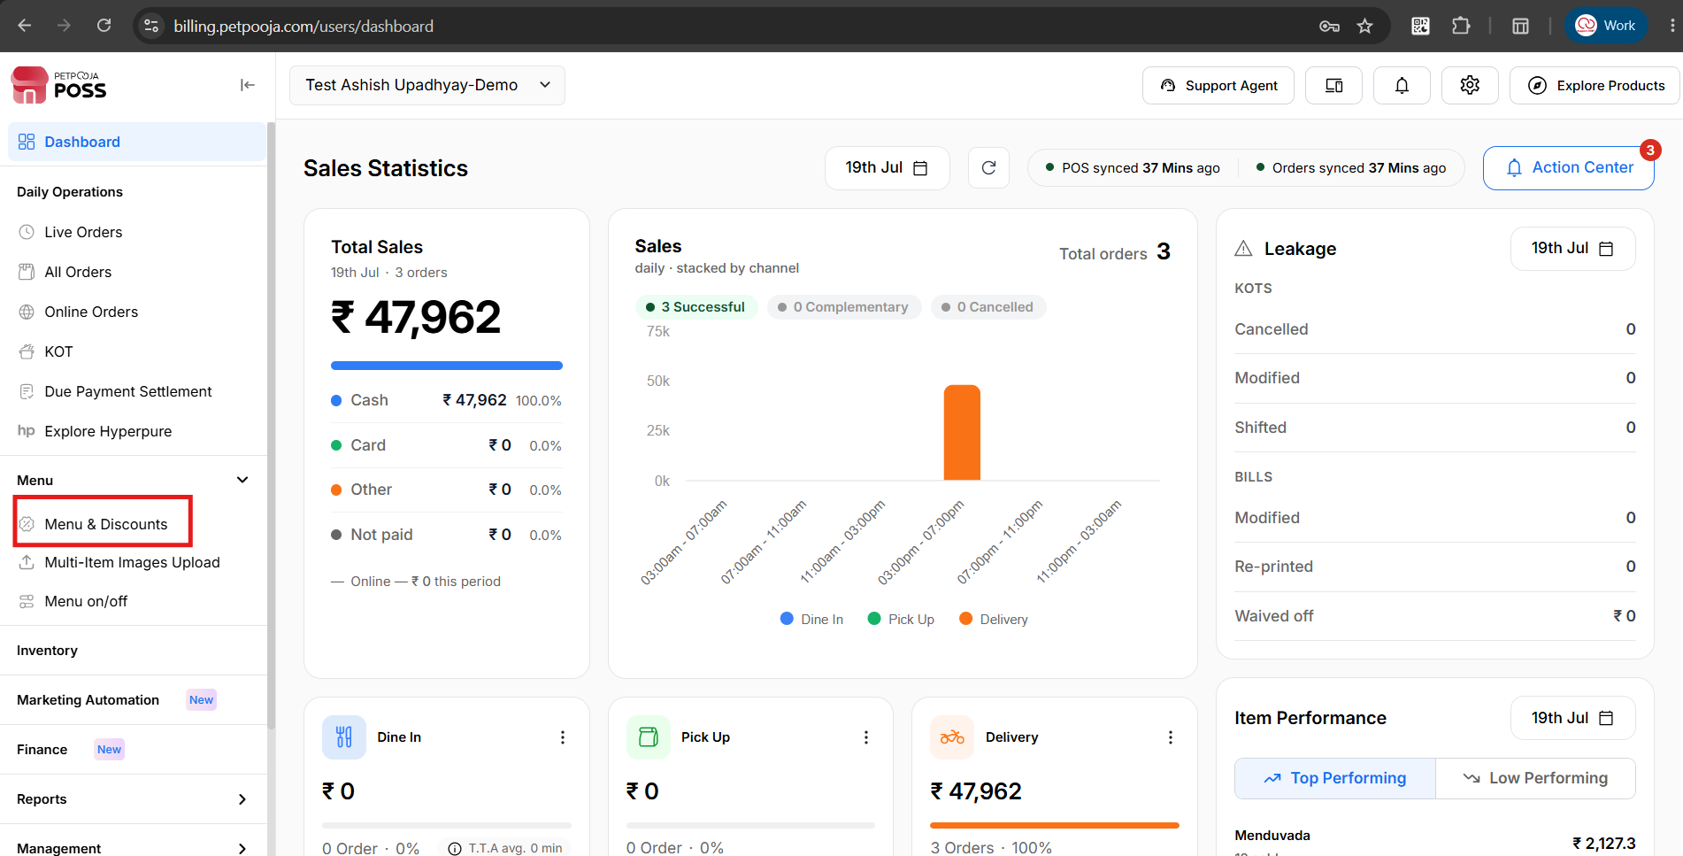
{Image Name: Menu & Discounts,
Description:Here is an image showing the screen highlighting the "Menu & Discounts" option under the Menu section.Here is an image of step 3 Menu & Discounts in Steps to reach Set Item Commission.}
Step 4 : Set Item Commission in Steps to reach Set Item Commission : Inside Menu & Discount, click on Set Item Commission.
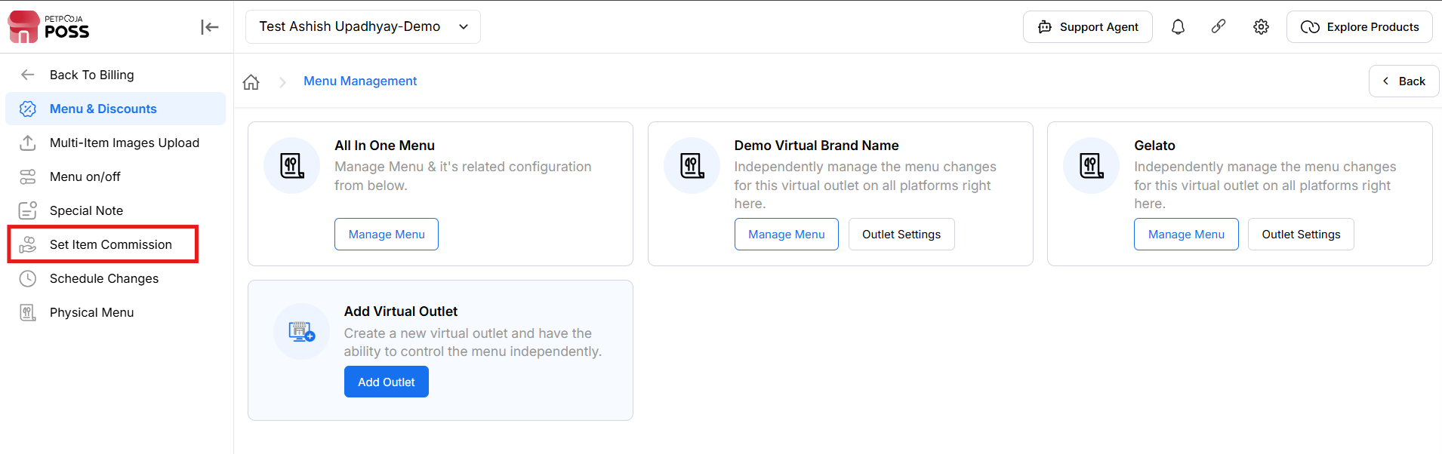
{Image Name: Set Item Commission Page,
Description: Here is an image showing the Set Item Commission section in the PetPooja dashboard.Here is an image of step 4 Set Item Commission in Steps to reach Set Item Commission.}
Key features Of Set Item Commission :
outletwise_link : https://menu.petpooja.com/items/menucommission_list//
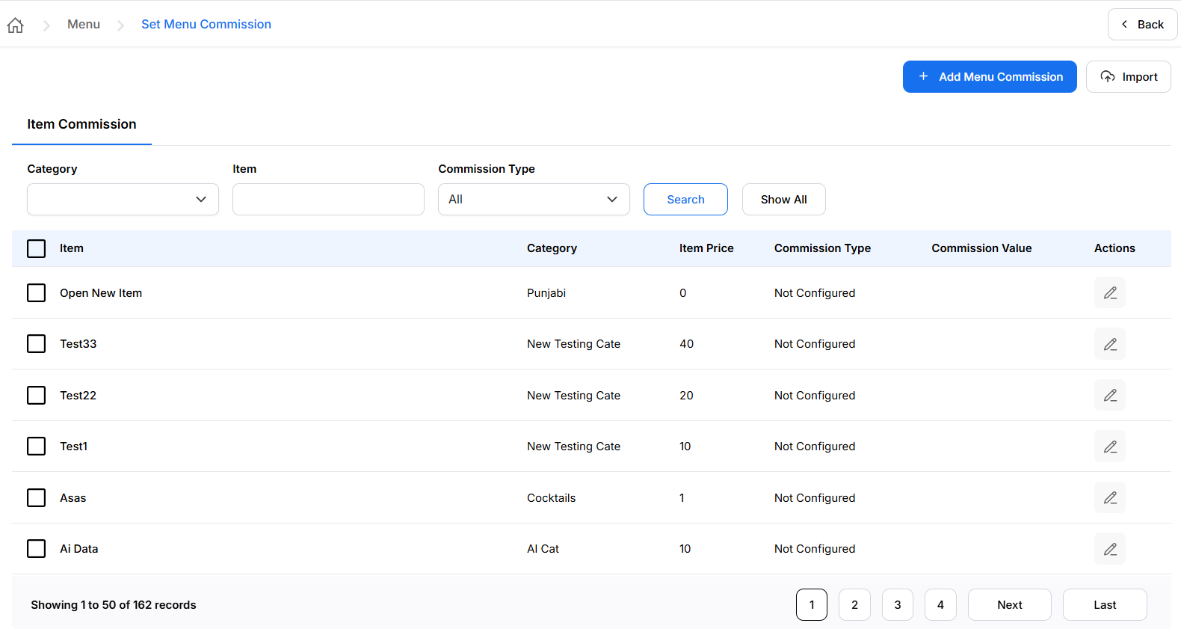
{Image Name: Item Commission Screen,
Description: Here Is an image displaying the “Item Commission” setup where users can manage commission settings for menu items.}
Search Section (Set Item Commission) :
outletwise_link : https://menu.petpooja.com/items/menucommission_list//
- (Search Section) Category Dropdown: Filter items based on their assigned category.
- (Search Section) Item Field: Type the name of a specific item to search for it.
- (Search Section) Commission Type Dropdown: Choose the type of commission you want to filter by.
- (Search Section) Search Button (Red): Click this after entering your filters to apply the search.
- (Search Section) Show All Button: Click this to clear filters and show every item/commission.
- (Search Section) Import Menu Commissions :The Import button allows you to upload multiple commission settings at once using a pre-defined file format. This is useful for managing large menus efficiently.

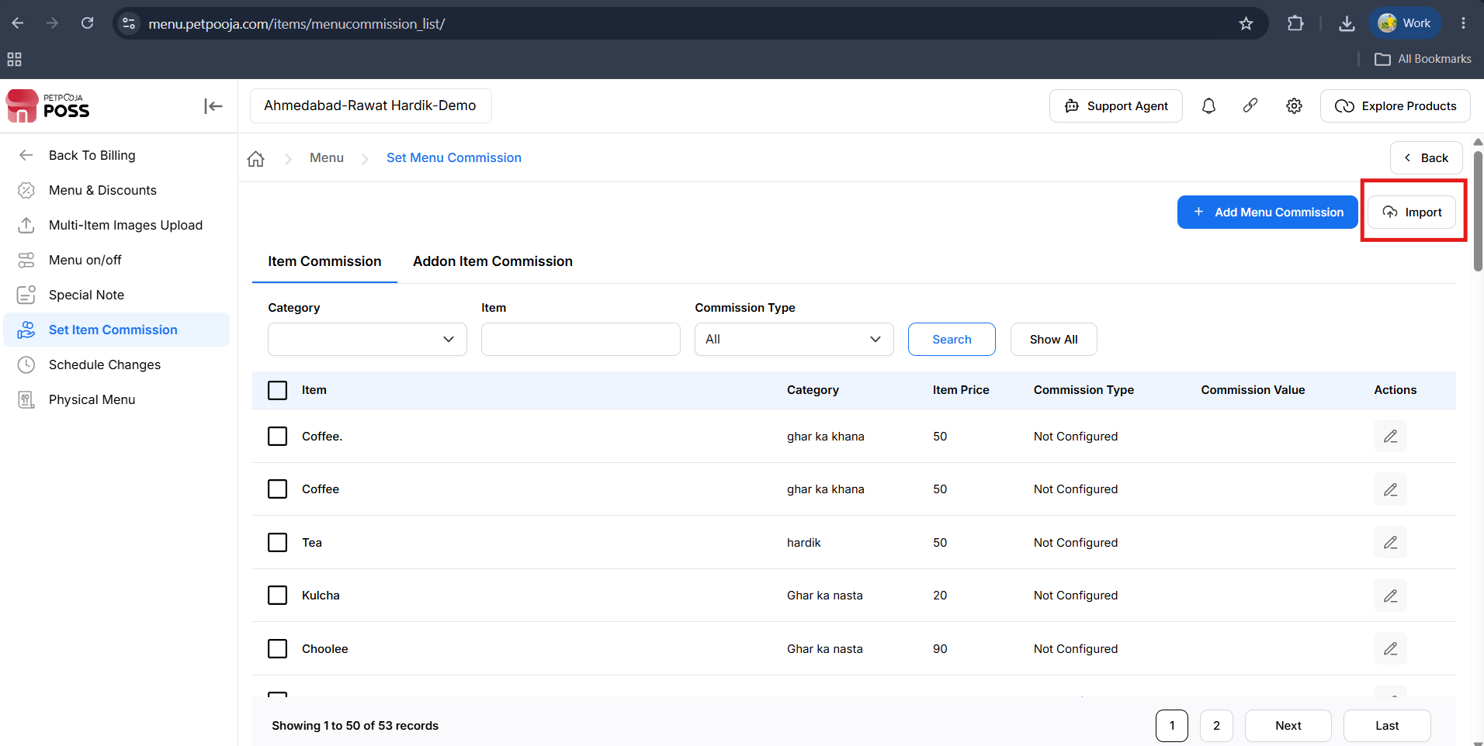
{ Image name : import option for bulk commission add
Description : Click the Import button to upload the menu commission file. After importing, the commission details will be applied to the selected items. }
Add Menu Commission (Set Item Commission) :
outletwise_link : https://menu.petpooja.com/items/menucommission_list//
1.Select Item (Add Menu Commission) : Select Item that you have to Add Item Commission
You must select one of the three types (Add Menu Commission) :
- None: No commission will be applied to the item.
- Percentage : Apply a percentage-based commission (e.g., 10%).
- Fixed : Apply a fixed commission amount (e.g., ₹.5).

Buttons (Add Menu Commission) :
outletwise_link : https://menu.petpooja.com/items/menucommission_list//
- Submit (Buttons) : Saves your selected commission type and applies it to the item.
- Cancel (Buttons) : Closes the popup without saving changes.

View Menu Commission List (Add Menu Commission) :
outletwise_link : https://menu.petpooja.com/items/menucommission_list//
Once on the Menu Commission page:
- A list of menu items will be shown in a table format.
- Each row represents an individual item with the following details:
  - Item: Name of the food or menu item.
  - Category: Type or group (e.g., PIZZA).
  - Item Price: Current price.
  - Commission Type: Shows if commission is configured (None / Percentage / Fixed).
  - Commission Value: Displays value if configured.
  - Actions: Includes an edit option for updating settings.

Edit an Item’s Commission (Add Menu Commission) :
outletwise_link : https://menu.petpooja.com/items/menucommission_list//
To configure or update commission settings:
- (Edit an Item’s Commission) Click the Edit (pencil icon) in the Actions column.
- (Edit an Item’s Commission) A "Set Menu Commission" popup will appear.
- (Edit an Item’s Commission) Select a Commission Type :
  - None – No commission will be applied.
  - Percentage – Define a percentage value (e.g.,10%).
  - Fixed – Enter a fixed amount (e.g., ₹5).
- (Edit an Item’s Commission) Click Submit to save changes.
Note (Set Item Commission) : If any changes are made in the Schedule Changes from the dashboard, manual sync is mandatory in POS/Billing Application.

Set Addon item commission :
Note: The Addon Item Commission feature is available only in Petpooja POS version 125.0.1 or later. Please make sure your POS is updated to version 125.0.1 or above before using this feature.

Path : Billing.petpooja.com >> Menu >> Menu & Discount >> Set Addon item Commission.
outletwise_link : https://menu.petpooja.com/items/menucommission_list//
Steps to reach Set Addon item Commission :
Step 1 : Billing.petpooja.com in Steps to reach Set Addon item Commission : Open your browser and go to billing.petpooja.com.

{Image Name: PetPooja Dashboard ,
Description: The highlighted URL indicates that this is the billing.petpooja.com.Here is an image of step 1 Billing.petpooja.com in Steps to reach Set Addon item Commission.}
Step 2 : Menu in Steps to reach Set Addon item Commission : Click on the Menu section from the dashboard.

{Image Name: Menu,
Description:This screen shows the Petpooja dashboard with the "Menu" section highlighted. Here is an image of step 2 Menu in Steps to reach Set Addon item Commission.}
Step 3 : Menu & Discount in Steps to reach Set Addon item Commission : Inside the Menu section, click on Menu & Discount.

{Image Name: Menu & Discounts,
Description:Here is an image showing the screen highlighting the "Menu & Discounts" option under the Menu section.Here is an image of step 3 Menu & Discounts in Steps to reach Set Addon item Commission.}
Step 4 : Set Item Commission in Steps to reach Set Addon item Commission : Inside Menu & Discount, click on Set Addon Commission.

{Image Name: Set Item Commission Page,
Description: Here is an image showing the Set Item Commission section in the PetPooja dashboard.Here is an image of step 4 Set Addon item Commission in Steps to reach Set Addon item Commission.}

Step 5 : Set Item Commission in Steps to reach Set Addon item Commission:
After that, click on the Add-on Item Commission option.

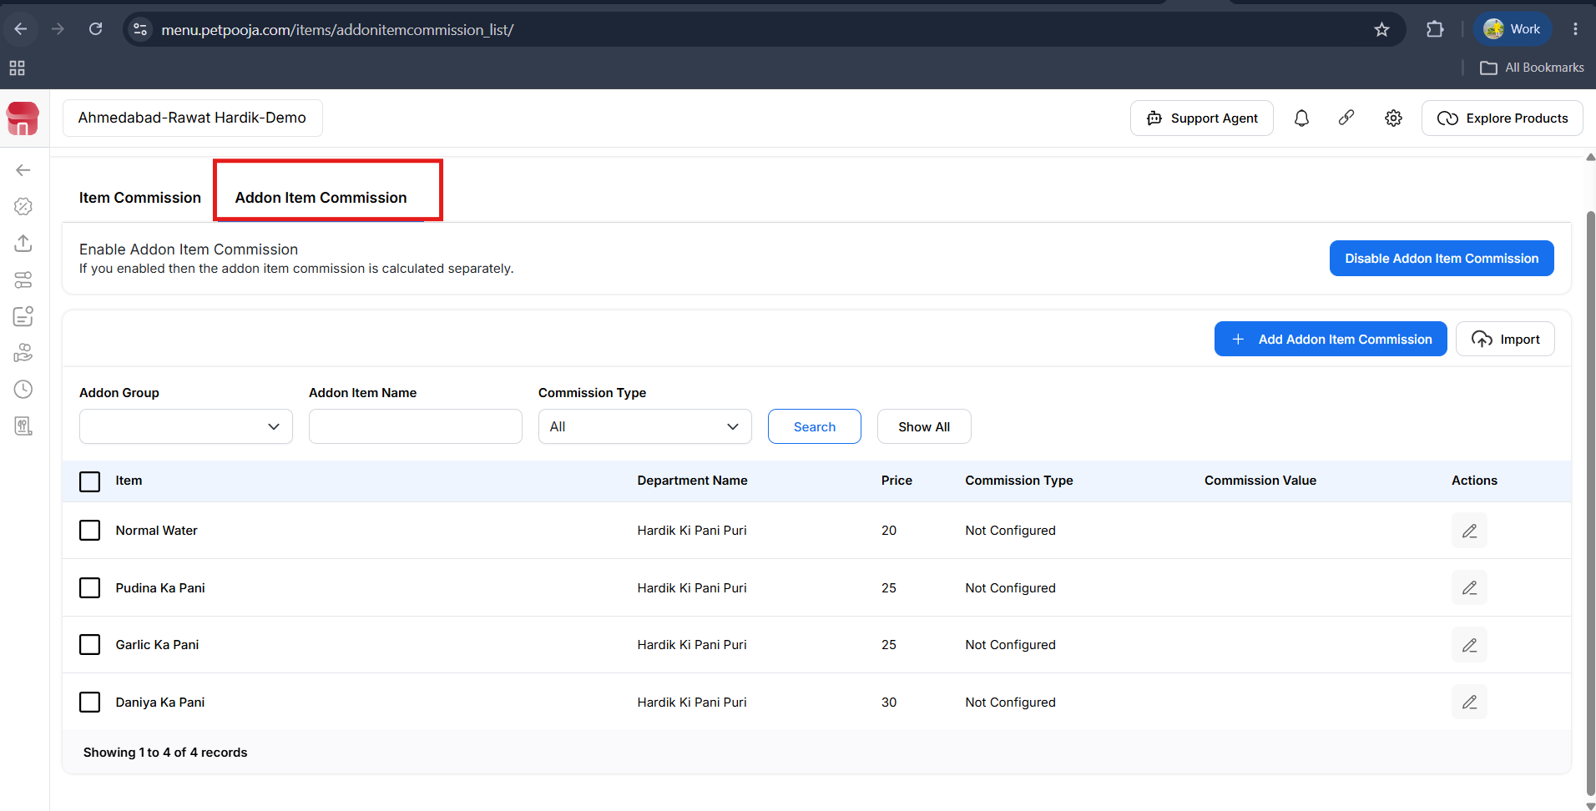
{ Image Name : Addon item commission
Description : Here is an image showing addon item commission in the petpooja dashboard hear is an image of step 5 set addon item commission in step to reach set addon item commission.}

Step 6 : Set Item Commission in Steps to reach Set Addon item Commission:After that, enable the Add-on Item Commission option. Once enabled, all of your add-on options will be displayed.

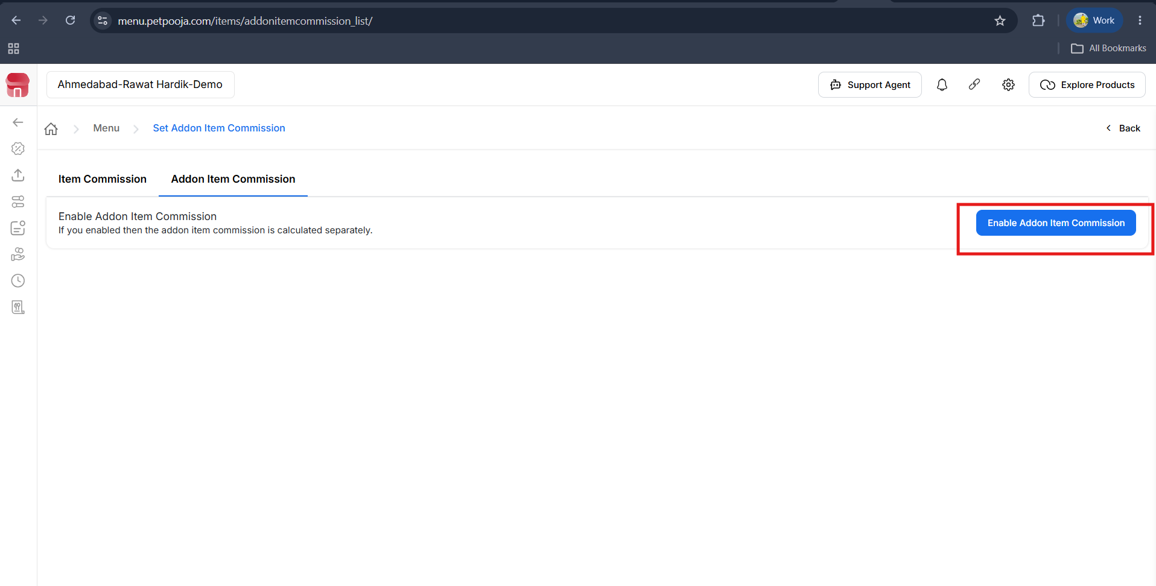
{ Image Name : enable the Add-on Item Commission option
Description : This screen is used to enable Add-on Item Commission. Click the Enable Addon Item Commission button to activate this feature. Once enabled, all available add-on items will be displayed, allowing you to set individual commission percentages for each add-on item separately.

Step 7 : Set Item Commission in Steps to reach Set Addon item Commission:
Use the search filters to quickly find the add-on items for which you want to set a commission.
- Addon Group – Search and filter add-on items by their add-on group.
- Addon Item Name – Search for a specific add-on item by its name.
- Commission Type – Filter add-on items based on their commission type.
Step 8 : Set Item Commission in Steps to reach Set Addon item Commission:
After finding the add-on item, click the Edit button (pencil icon) located at the end of the item.
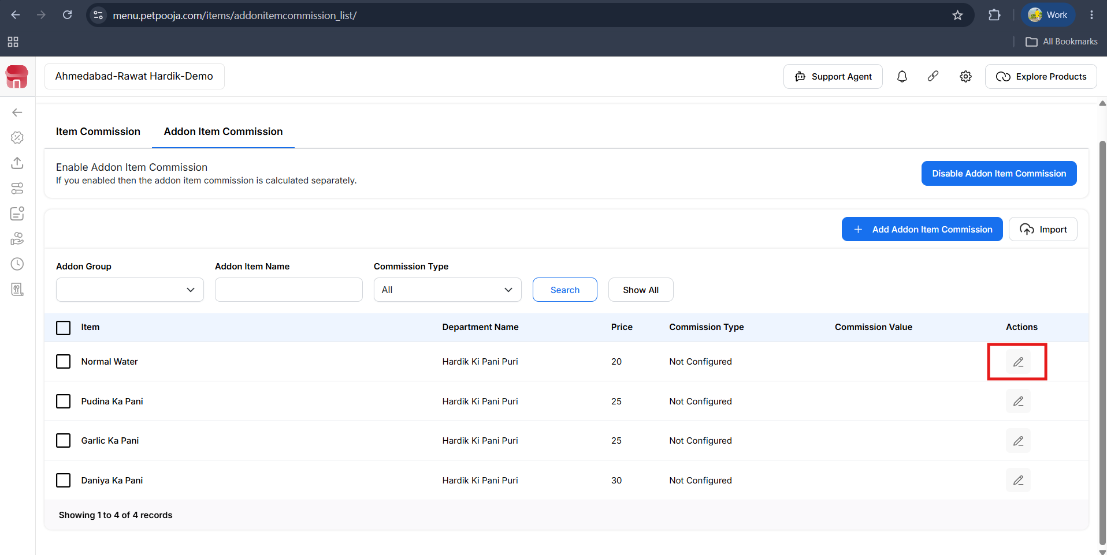
{ Image Name : Edit Add-on Item Commission
Description : This screen displays the list of add-on items available for commission configuration. Use the search filters (Addon Group, Addon Item Name, and Commission Type) to find the required add-on item. After locating the item, click the Edit (pencil) icon in the Actions column to configure or update its commission settings. }

Step 9 : Set Item Commission in Steps to reach Set Addon item Commission:
After clicking the Edit (pencil) icon, you will see three Commission Type options: None, Percentage, and Fixed. Select the option you want, enter the commission value if required, and click Submit to save the changes."

Commission Type Options
- None – No commission will be applied to the selected add-on item.
- Percentage (%) – The commission will be calculated as a percentage of the add-on item's selling price.
- Fixed – A fixed commission amount will be applied to the selected add-on item, regardless of its selling price.

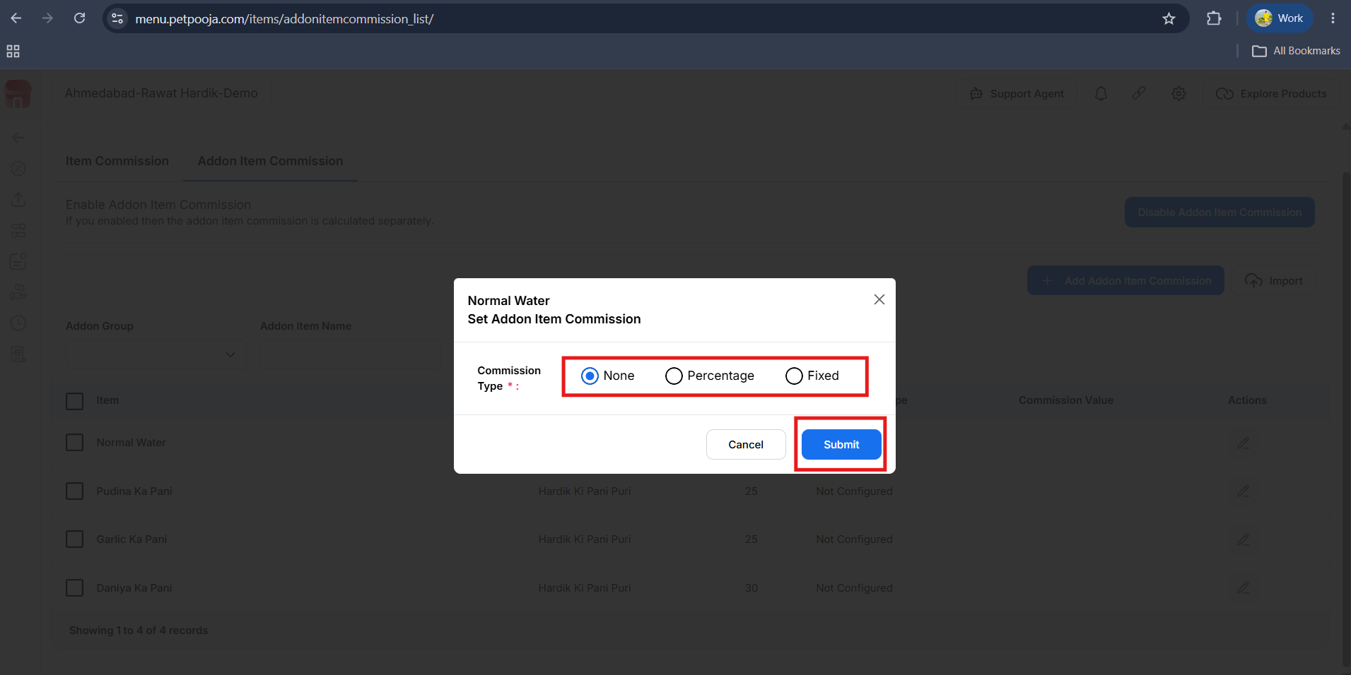
{ Image Name : Set Add-on Item Commission
Description : This pop-up allows you to configure the commission type for the selected add-on item. Choose one of the available commission options—None, Percentage, or Fixed—based on your requirement. If you select Percentage or Fixed, enter the required commission value, then click Submit to save the changes. Click Cancel to close the pop-up without saving.
If you want to add an Addon Item Commission to all addon items on a page at once, it is also possible. Simply select the required addon items, click the Add Menu Commission button, and then set the commission from there. The selected commission will be applied to all the selected addon items simultaneously.
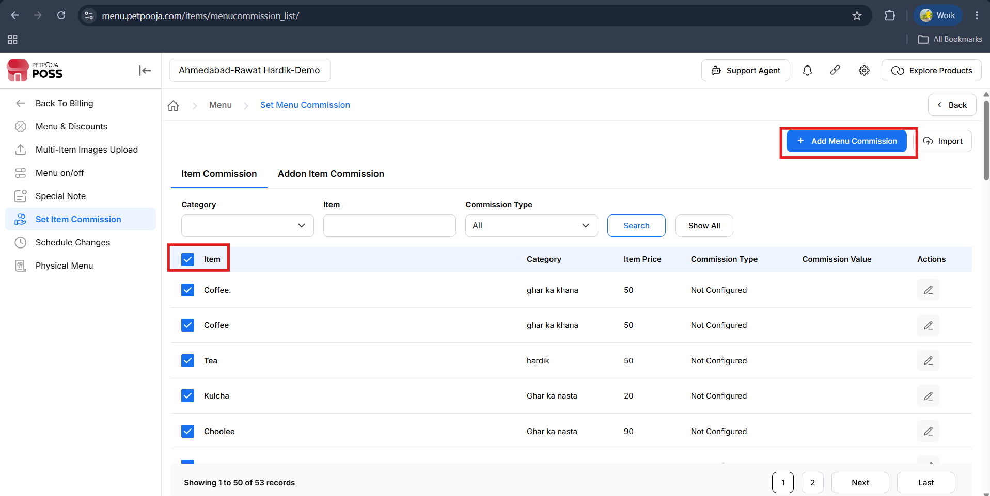
{ Image Name : Bulk Add Menu Commission
Description : To add a commission to multiple menu items at once, first select the required items using the checkboxes on the left side. You can also use the top checkbox to select all items displayed on the current page. After selecting the items, click the Add Menu Commission button to set the commission for all selected items in a single action. This helps you save time by updating multiple items at once instead of configuring each item individually.
- You also have a Bulk Sheet option available. On the right side of the screen, you will see the Import button. Simply click on the Import button to upload the bulk sheet and update commissions for multiple items at once.
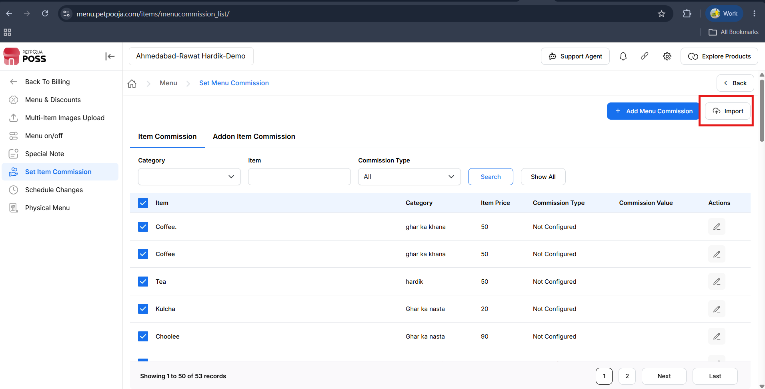
{ Image Name : Import Bulk Commission Sheet
Description : Click the Import button on the right side of the screen to upload a bulk commission sheet. This option allows you to import commission details for multiple menu items at once, making it quick and easy to update commissions in bulk instead of configuring each item individually. }
- After that, you will see the Download Item List option. Simply click on it to download the item list.
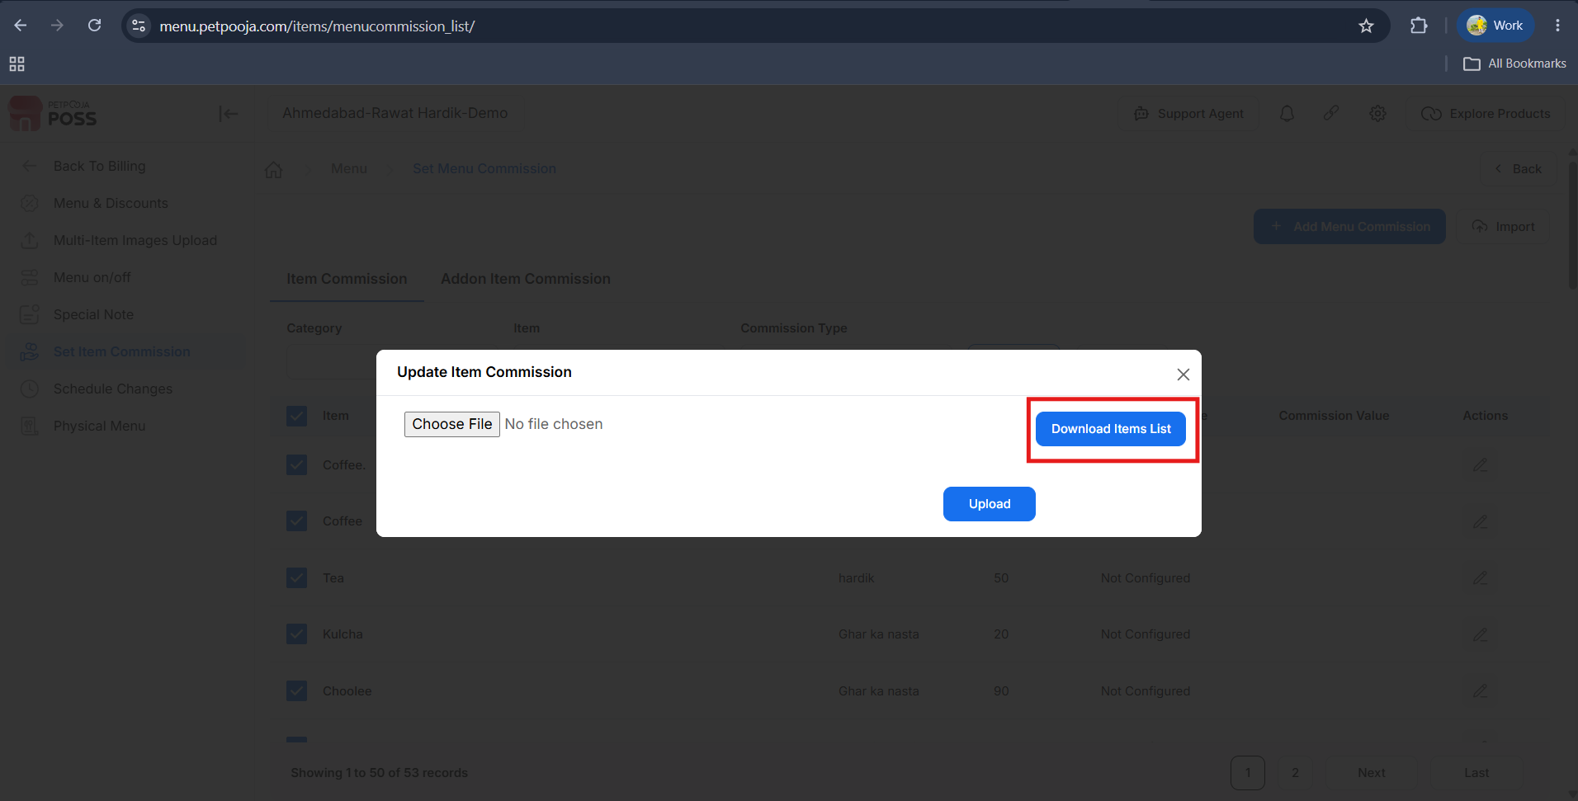
{ Image Name : Download Items List
Description : Click the Download Items List button to download the item commission template. This file contains the list of menu items and can be used to update commission details in bulk. After making the required changes in the downloaded file, save it and upload it using the Choose File and Upload options. }
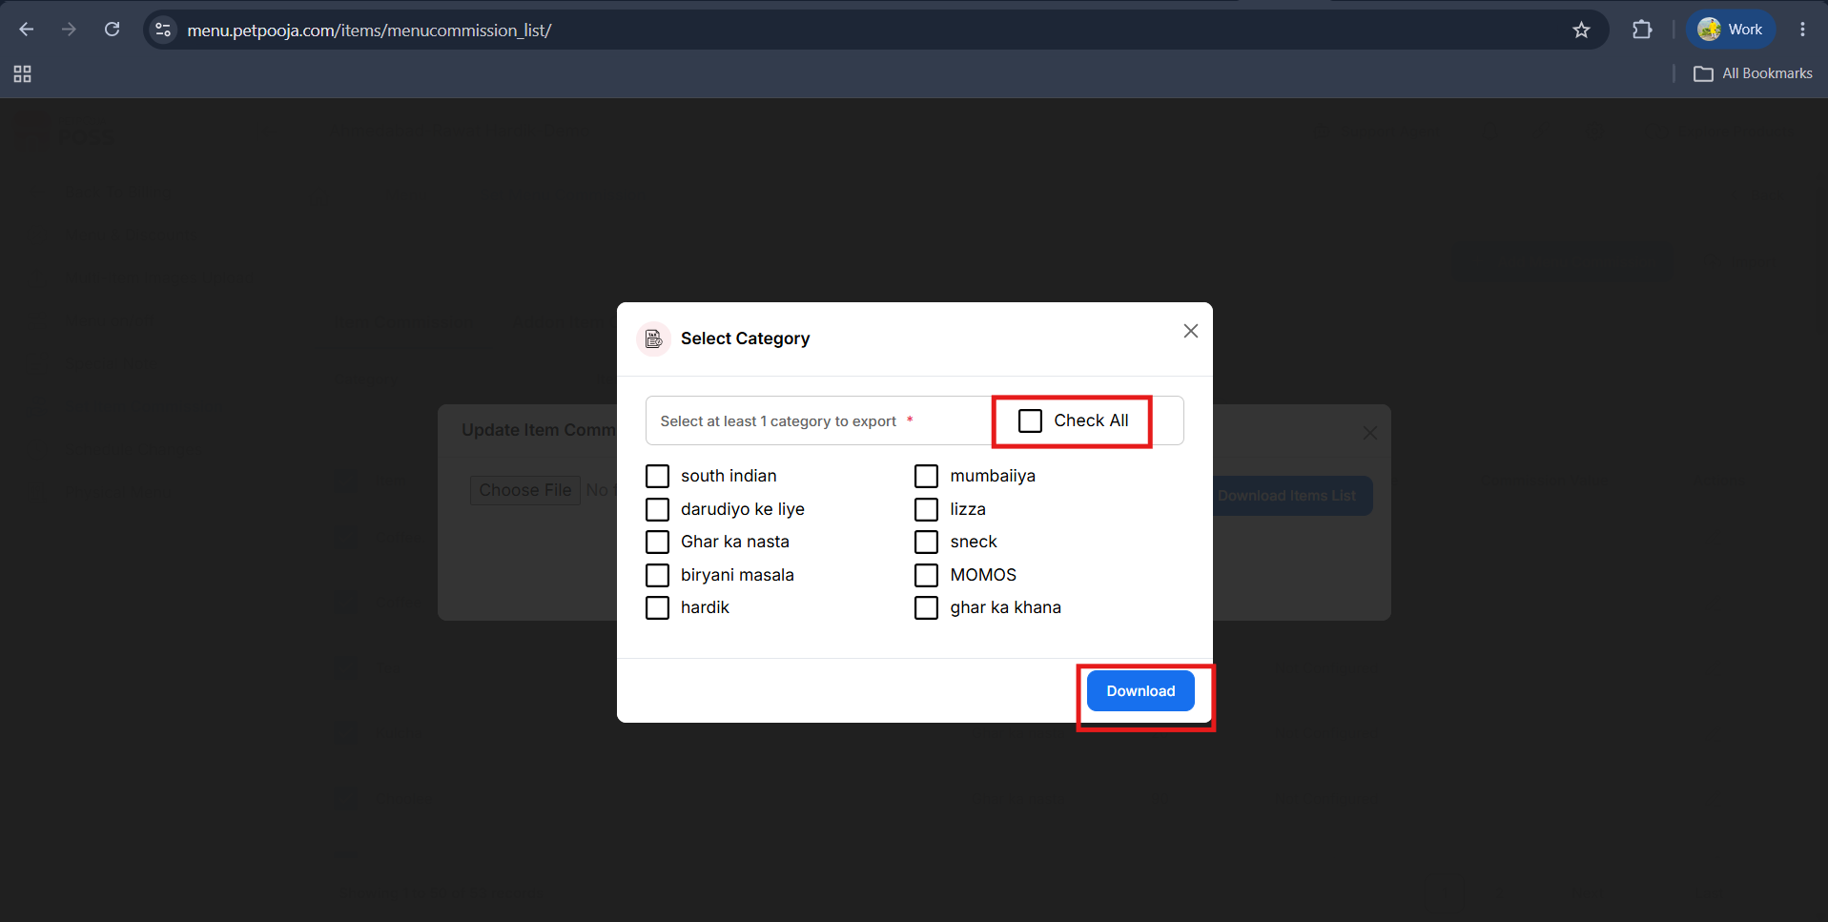
{ Image Name : Select Categories for Download
Description : Select the categories you want to include in the downloaded item list. You can choose individual categories or click the Check All option to select all categories at once. After selecting the required categories, click the Download button to download the item list for the selected categories.}

- After clicking Download, the file will be downloaded to your device. Open the downloaded file and enter the required commission values only. Once you have updated the file, click the Choose File button, select the edited file, and then click Upload to apply the commission updates.
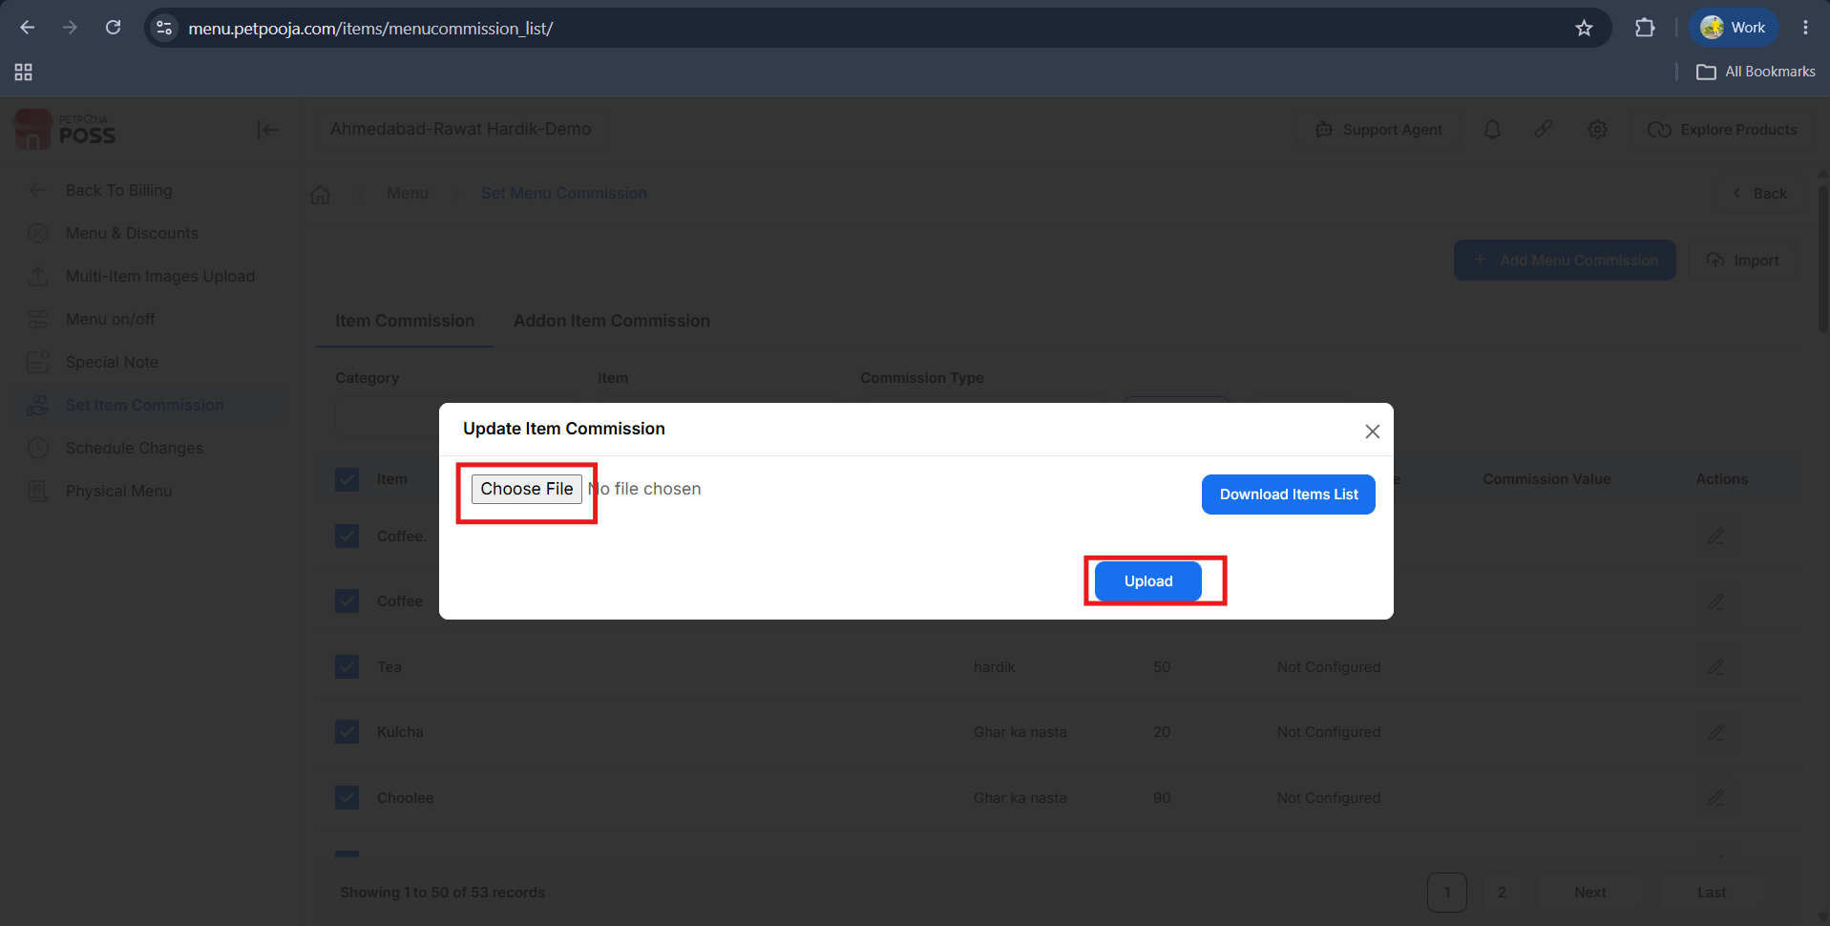
{ Image Name : Upload Bulk Commission File
Description : Click the Choose File button and select the updated commission file from your device. After selecting the file, click the Upload button to upload it. The system will process the file and apply the commission updates to all the items included in the uploaded sheet. }
Note: The file must be updated in the same format in which it was downloaded. Do not change the file structure or format. After uploading the updated file successfully, perform a Manual Sync on the Main Server to apply the changes.

